10.1.9 Editors - Geometry Nodes Editor - Header - Add Menu - Input
Detailed table of content 1
Add menu - Input 1
Object Info 2
Random Float 2
Value 3
Vector 3

Detailed table of content
Detailed table of content
Detailed table of content 1
Add menu - Input 1
Object Info 2
Inputs 2
Object 2
Outputs 2
Location 2
Rotation 2
Scale 2
Geometry 2
Random Float 2
Inputs 2
Min 2
Max 2
Seed 2
Outputs 2
Value 2
Value 3
Properties 3
Outputs 3
Value 3
Vector 3
X Y Z 3
Output 3
Vector 3

Add menu - Input
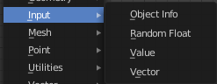
Here you find input nodes.

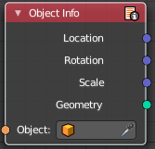
Object Info
The Object Info node retreives information from objects. And outputs it then.

Inputs

Object
Object to get the properties from.

Outputs

Location
Location of the object in world space.

Rotation
Rotation of the object in world space.

Scale
Scale of the object in world space.

Geometry
Geometry of the object in world space with all its modifiers applied.

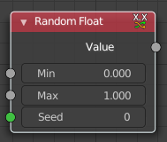
Random Float
The Random Float generates a random (floating point) value from a given range.

Inputs

Min
Minimum random value.

Max
Maximum random value.

Seed
The random seed.

Outputs

Value
The random generated value.

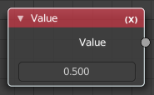
Value
Input numerical values to other nodes in the tree.

Properties
Single numerical value (floating point).

Outputs

Value
The value set in the node properties.

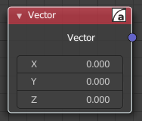
Vector
Creates a single vector of three values that can be used as an input.
Properties

X Y Z
The values of the vector.

Output

Vector
Standard vector output.

